Shane Riegodedios

Ryan Leroux

Dr. Torben

Intro to Algorithm Analysis – Assignment 2

1.

1. M(3) = 3

M(4) = 3

M(5) = 3

M(6) = 3

M(7) = 3

M(8) = 4

1. M(n) = 1 + M(n-1)

2.

f(n) = 1000000

f(n\*ln(n)) = 87,847.5

f($n*√$ n) = 10,000

f($n^{2}$) = 1,000

f($n^{3}$) = 100

f(${1.1}^{n }$) = 144.95

f($2^{n }$) = 19.93

f($n!$) = no solution

f($n^{n}$) = 7.066

3.

1.

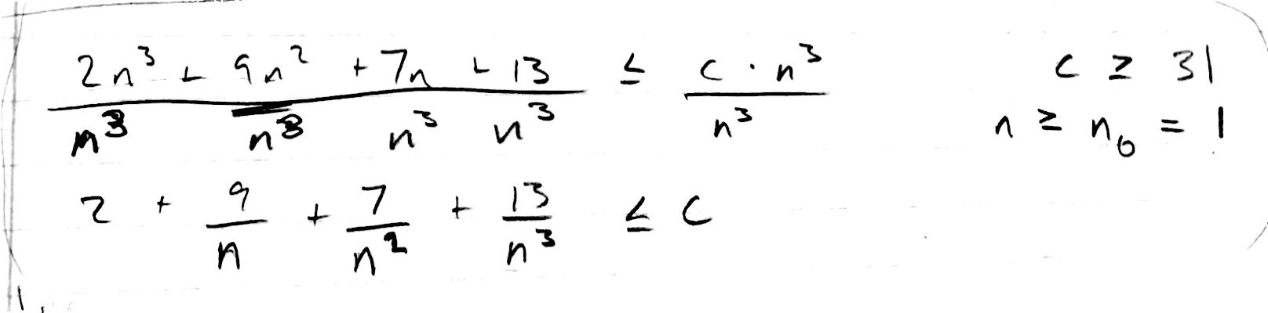

2.